Instructional Design Final Project
Using Google Chrome Music Lab to Enhance Music Learning in the Elementary Classroom

Kiely Kingsbury
Department of Instructional Design & Performance Technology, Baker University
IDPT 5000: Foundations and Issues in Instructional Design, Performance Technology, and Human Performance
Dr. Tina Parscal
June 12th, 2022

Table of Contents

Topic………………...…………………………………………………………………………… 3
Instructional Analysis………………………………………………………………………… 3 - 8
Needs Assessment……………………………………………………………………. 4 - 5
Problem Identification…………………………………………………………………… 6
Task Analysis………………………………………………………………………… 6 - 7
Learner Profile……………………………………………………………………………8

Instructional Design………………………………………………………………………… 8 - 13
Learning Outcomes……………………………………………………………………… 8
Instructional Strategy……………………………………………………………………. 9
Content Sequence…………………………………………………………………...10 - 11
Instruction Plan…………………………………………………………………………. 12
Resources…………………………………………………………………………… 12 -13
Assessment Strategy……………………………………………………………………. 13

Instructional Development………………………………………………………………… 14 - 19
Development Plan…………………………………………………………………. 14 - 15
Sample Instruction…………………………………………………………………. 15 - 16
Sample Assessment………………………………………………………………... 17 - 19

Implementation Plan……………………………………………………………………….. 19 - 21

Evaluation Strategy………………………………………………………………………… 21 - 22
Formative Evaluation…………………………………………………………………… 23
Summative Evaluation………………………………………………………………….. 23

References……………………………………………………………………………………… 24
Appendix……………………………………………………………………………………….. 25

Instructional Analysis
Topic
This design project will be a workshop geared toward current elementary music educators who want to enhance their pedagogy and curriculum engagement in their classrooms. It will demonstrate the benefits of using Google Chrome Music Lab and how to utilize it effectively to enhance music literacy, creativity, engagement, and inclusivity in the music room. The lesson will focus primarily on using the Google Songmaker app as a way to teach music literacy at the elementary level beginning with kindergarten (ages 5 and 6) and ending with 5th grade (ages 10 and 11). Then it will expand into utilizing Google Songmaker as a way to encourage creativity, engagement, and inclusivity in the music room through informal music learning and the integration of popular music.

The workshop will take place over three days during the summer from 8-5 pm. Day one will be an introductory course on how to use Google Songmaker and its benefits in the classroom. Students will experiment with Google Songmaker and learn to transcribe a song of their choice using the color-coded music literacy system. Day one will conclude with a formative assessment of a student's ability to correctly transcribe a song from traditional music notation to Google Songmaker. On day two, participants will be broken into groups to design a music unit of their desired content. During this time students will receive feedback and advice from instructors and will have time to practice and revise their presentation for day three. On day three, students will finish their group project, and present their unit to the rest of their peers. Here, they will receive feedback, answer questions, and demonstrate their comprehension of the workshop. After presentations, students will complete a discussion post via a learning management system called, “padlet.com” (see Appendix A). Students will synthesize what they learned from the workshop and discuss how it can transfer to their classrooms while collaborating with other students in the course.

Needs Assessment
Purpose: This curriculum will improve pedagogy styles and music literacy in elementary music classrooms. It will expose music educators to a new and unique way of teaching music literacy in the elementary music classroom. Additionally, it will enhance their current teaching practices and create a more holistic and inclusive curriculum.
Observed Needs: In the current music education curriculum, the pedagogy surrounding music literacy relies on memorization and regurgitation instead of comprehension and retention. Music educators need a more concise and consistent method of teaching music literacy to enhance their curriculum and increase retention rates amongst young learners.

Phase I- Planning
The target audience will consist of current music educators in the states of Kansas and Missouri who have enrolled in the course as part of an optional professional development course provided during the summer. Participants will be informed of this workshop during the National Music Conferences held during the spring semesters through the Kansas Music Educators Association (KMEA) and Missouri Music Educators Association (MMEA). Participants will have the option to attend a condensed version of this workshop, but it will not be required. Participants will have the option to sign-up for this course at the music conference or through their district’s Fine Arts Coordinator. Additionally, virtual sign-ups via Google Forms will be sent out to music educators in the greater Kansas City metro area. The sign-ups will include a brief questionnaire regarding demographic questions such as age, teaching experience, education, etc. The questionnaires will also be used during the evaluation process at the end of the workshop. The sign-ups will close once 65 members have opted to join the course.

Phase II - Collecting Data
Sample size - This would involve the 65 music educators who signed up for the course. A select group of music education professors from surrounding universities (i.e. University of Kansas, University of Missouri-Kansas City, Kansas State University) would be contacted for their input as well.
Collecting Data - After collecting the contact information of the 65 individuals from the questionnaire during the sign-up process, a pre-survey would be sent out to participants regarding their knowledge of Google Songmaker, how they currently utilize technology in their classrooms, their current pedagogy practices of music literacy, and their integration of diverse genres and cultures in the classroom. Additionally, the pre-survey would ask students to discuss what they hope to gain from the course and what questions/concepts they want better explained.
Conducting Meetings - Instructors and the workshop design team will collaborate with current music education professors of surrounding universities to identify the relevance of the subject matter and how to integrate current music literacy pedagogies with this new system. Likewise, collaborate with music curriculum design experts on the inclusion of the National Music Standards in the course’s curriculum.

Phase III - Data Analysis
Analyze Data: Examine students’ responses to the pre-survey and work with subject matter experts (SMEs), music education professors, and music curriculum designers, to determine the relevance of the course by utilizing diagnostic analytics and prescriptive analytics. Next, work with SMEs to determine the scope and sequence of the course so it adheres to the learning outcomes of the workshop and incorporates the trends in students’ personal learning goals regarding the course.

Phase IV - Evaluating Data
*Note: The following data is based on projected numbers and statistics; the numbers reported are entirely theoretical and meant to be used only to provide context for the rest of the design project.
Final Report: Based on the data collected through the pre-survey, the report concluded that 84% of the participants showed a relevance and desire for a course enhancing their music literacy pedagogy styles. The report also indicated that 90% of participants had never used Google Chrome Music Lab or Google Songmaker as an instructional tool in their classroom. None of the participants indicated an ability to transcribe a song into Google Songmaker. The meetings with SME showed a need for a new way to teach music literacy in the elementary classroom as well as an eagerness to include more diverse genres and cultures in the music curriculum.
Recommendations: Based on the data, this workshop is necessary to address the need and desire for a more expansive and inclusive music literacy curriculum.

Problem Identification
As a first-year music teacher, it can be overwhelming to think about all the content and standards that have to be taught during a single year to a diverse range of grade levels while still accommodating all the students and maintaining student engagement and participation. Through my experience as a music teacher, and the observation of other music teachers, I discovered a common problem in teaching music literacy - there was little comprehension and barely any retention. Additionally, current music literacy pedagogies lack engagement and the inclusion of different music genres, especially popular music. As a student-teacher, my cooperating teacher introduced me to a unique way of designing lessons to enhance music literacy and music genre exposure in his classroom by using Google Chrome Music Lab and its Google Songmaker app. This workshop’s goal is to expose music educators to the benefits of using Google Chrome Music Lab in their classrooms and how to use Google Songmaker to increase music literacy, enhance student engagement, and improve genre inclusivity in their classrooms.

Task Analysis
Below are the tasks participants will complete throughout the course followed by a topical and procedural analysis defining the connections and relationships between the concepts and principals making up the content of the workshop. An assessment strategy is listed to evaluate the learner's understanding at the end of each task.

Tasks
- Learning about Google Songmaker
  - Objectives:
    - Explore Google Chrome Music Lab and Songmaker
      - Act as students during a mock lesson using Google Songmaker demonstrated by the instructor
    - Identify popular songs via Google Songmaker
      - Identify various popular songs by listening to various Songmakers created by the instructor
    - Identify music concepts to be taught utilizing Google Songmaker
      - Identify and discuss music concepts taught during mock lesson
      - Discuss with peers other concepts that could be taught in future lessons
  - Assessment Strategy: verbal informal formative
- Utilizing Google Songmaker
  - Objectives
    - Introduce the color-coded music literacy system used in Songmaker
    - Transfer traditional music notation into Songmaker
      - Practice composing a short melody on Songmaker
      - Transfer short melody into traditional music notation
    - Transcribe a short melody into Songmaker
      - Practice melody on Boomwhackers, xylophones, or piano
      - Play instruments while using Songmaker as a tool
  - Assessment Strategy: demonstrative formative
- Teaching with Google Songmaker
  - Objectives
    - Work in groups to design and develop a group mini-lesson unit using Google Songmaker
    - Present and teach their mock group lesson to the participants in the course
      - Create a 20-minute mock group lesson
      - Use the songs participants transcribed earlier in course
      - Identify music concepts to be taught
      - Rehearse presentation
      - Perform and receive feedback from peers
    - Reflect on the mock lesson
      - Receive feedback from peers and group members
      - Describe possible revisions for the future
  - Assessment Strategy: demonstrative summative
- Synthesizing Google Songmaker in the classroom
  - Objectives:
    - Summarize concepts taught during workshop
      - Complete discussion post
      - Respond to peers
    - Self-reflect on group project
      - Complete survey
      - Provide constructive feedback
    - Synthesize how to use Songmaker in their own music classroom
      - Describe future lessons using Songmaker
      - Provide various music concepts to be taught with Songmaker
  - Assessment Strategy: informal summative

Learner Profile
A learner profile will be developed through an analysis of the data collected through the needs assessment during the pre-survey. The workshop is projected to include participants between the ages of 23 and 52 with a bachelor’s degree in music education. They will have been licensed to teach elementary music in Kansas or Missouri. All participants will have been teaching for 3+ years in elementary music and understand the current music curriculum and pedagogy curriculum. Approximately 70% of participants are estimated to identify they are, “kinesthetic learners”, 20% identify as, “visual learners”, and 10% identify as “auditory learners”. Additionally, it is estimated that 90% of participants will describe their knowledge of Google Songmaker and its use as an instructional tool as “lacking”. The design of this project will accommodate the different types of learning styles through constructivist approaches utilizing interactive learning environments, problem-based learning, collaborative instruction, and student-centered learning.

Instructional Design
Learning Outcomes
Learning Outcome 1: Students will demonstrate an understanding of Google Songmaker by transcribing a song into Google Songmaker using the color-coded music literacy system described in the workshop.
Learning Outcome 2: Students will work together in groups to create a 4 lesson music unit focusing on a music standard and content (i.e. melody, harmony, form, or rhythm) of their choice using the songs they transcribed in “Learning Outcome 1” as a resource.
Learning Outcome 3: Students will work together in their groups to present and perform their music unit created in “Learning Outcome 2”.
Learning Outcome 4: Students will synthesize their learning and describe how they will apply Google Chrome Music Lab and Google Songmaker in their music classroom by completing a discussion post.

Instructional Strategy
Participants in this course will begin the workshop in a teacher-centered, lecture-based, learning environment. The lecture-based instructional strategy will only be used at the beginning of the course during the introductory lesson about Google Songmaker and how to transcribe music into the color-coded literacy system. The instructional strategies will gradually shift into more collaborative learning and indirect instruction as students work together to transcribe music and discuss musical concepts taught during the mock lesson. The instructional strategies throughout the course will continue to revolve around collaborative and cooperative learning as students work together to complete their group music unit project. The instructional strategies expand into experiential learning as students present and perform their final project to their peers and teach their music unit. Additionally, at the end of the workshop, the instructional strategy becomes an independent learning strategy with interactive instruction as students summarize and synthesize their learning.

The instructional strategies in this course are largely student-centered and focus predominantly on cooperative and collaborative learning during group projects. These instructional strategies aim to provide students with an inclusive and interactive learning environment. These approaches rely heavily on constructivist models and, “emphasizes learners’ construction of meaning through collaboration and engagement with the world” (Reiser & Dempsey, 2017). The workshop is scaffolded and sequenced in a way that allows participants to transition from students themselves into independent and experienced learners. Utilizing these instructional strategies will not only create a more diverse and inclusive learning environment but also integrates more relevance to job and out-of-the-classroom performance.

Content Sequence
Day 1: Introduction of Google Songmaker & Transcribing Music
- Describe the purpose of the course and the goals of the workshop
- Introduce Google Songmaker and its benefits in the music literacy curriculum
- Perform a mock lesson utilizing Google Songmaker
  - Have participants listen to “Thunder” by Imagine Dragons and follow the moves of the instructor
  - Students will discuss the melodic and rhythmic components of the song that they found distinguishable
  - Without informing participants of the song title, have students listen to the Google Songmaker version of, “Thunder” by Imagine Dragons and see if participants can guess the correct song.
  - Have students practice body percussion and play along with Google Songmaker
  - Teach the chord progression and rhythm of “Thunder” by Imagine Dragons by utilizing Google Songmaker (see Appendix B)
  - Have students play Boomwhackers or color-coded xylophones with the Songaker
  - Informally assess students’ learning by having them demonstrate their ability to associate the colors of Google Songmaker with the colored Boomwhackers and play along with the Songmaker.
  - Discuss with participants what concepts and standards were taught during this lesson
- Present 2-3 other Google Songmakers and have participants guess the correct songs
  - Discuss the different concepts and/or music standards that could be pulled from each song (i.e. chord progression, rhythmic dictation, intervals, matching pitch, informal music learning, creating and improvising, etc. (see Appendix B)
- Introduce the color-coded music system of Google Songmaker and how it transcribes into traditional music notation
- Have students choose a short melody or song of their choice to transcribe into Google Songmaker
- Students break out into independent study groups to transcribe their melody
- After transcribing songs, students will come back together and exchange work to receive feedback, make revisions and collaborate
- The instructor will formally assess students' progress by listening to each of their Songmakers and providing constructive feedback

Day 2: Designing Group Lessons & Revision Process
- Students will be assigned a group project to create a 20-minute music lesson consisting of 4 mini-lessons (roughly 5 minutes long) over a music concept of their choice (harmony, melody, rhythm, or form)
- Students will work in groups to design their project with peers
- Students will have access to a rubric and mock unit outline to guide their design process (See Appendix C)
- Students will practice, rehearse, and revise their 20-minute lesson in preparation for the presentation on Day 3.
- Students will have the opportunity to perform a “rough draft” of their unit to peers at the end of the day
- Students will have optional hourly check-ins with instructors to provide constructive feedback and advice to groups throughout the day as they design their unit (an informal checklist will be used to guide evaluation)

Day 3: Presenting Group Lessons & Concluding Thoughts
- Students will have time to finish their group projects before presenting their lesson unit
- Students will present their lesson unit and teach their peers utilizing Google Songmaker as an instructional tool
- Students will receive feedback from peers, instructors, and group members before, during, and after their presentation
- After presentations, students will discuss the pros/cons are of utilizing Google Songmaker
- To conclude the workshop, students will complete a discussion post summarizing what they learned and synthesizing the information they gathered. Students will describe how they will use Google Songmaker in their classroom and respond to other peers' posts.
- Before leaving the workshop, students will complete an exit survey to evaluate their improvement after the course. The exit survey is a continuation of the pre-survey utilized in the needs assessment, however, it is followed by a brief questionnaire assessing the effectiveness of the course and the instructors.

Instructional Plan
The ADDIE Model will be used to design this workshop while integrating elements of the Inclusive ADDIE Model such as supporting structures, introspection, and a variety of interactions to increase student engagement and learning. Utilizing the content sequence and instructional strategies described above, teacher-centered instruction will be minimal due to the collaborative nature of the course. The lecture-based instructional strategy will only be used at the beginning of the workshop to introduce new concepts and explain the goals of the course. After the first day, instruction will become indirect and transition into a mentor-like approach that focuses on providing constructive feedback and guiding the student through their learning process. Likewise, the course concentrates on collaborative learning and meaningful performance that prepares students to transfer their learning into authentic real-world scenarios. During days two and three, the course will have a high degree of congruence between the learning environment and the context in which the actual knowledge and skills will be applied (i.e. participants' music classrooms). This type of instructional plan allows participants to synthesize and apply their learning to enhance their current pedagogy practice in the classroom.

Resources Needed
Technology - Technology such as a computer with an internet connection, SmartBoard, projector, and audio system will be necessary for the workshop to take place.
PowerPoint Presentation - A PowerPoint presentation will be used at the beginning of the course during the Songmaker Introduction lesson. It will also be used to provide a large portion of teacher-centered instruction.
Instruments - Instructors and students will need access to various types of instruments to demonstrate mock lessons, complete the group lesson unit, and practice and perform presentations. A brief list of instruments is described below:
- Xylophones, metallophones  - Handbells  - Boomwhackers | - non-pitched percussion  - Electronic keyboards  - Hand drums
iPads, Laptops, and Headphones - Participants will be informed before the workshop to bring their preferred technological device, however, iPads and headphones will be an optional accommodation for students who wish to use it as a resource and/or instructional tool as they design their lesson unit project. During the transcribing process on day one, participants may also need access to iPads and headphones to accurately listen and complete their work.

Assessment Strategy
The following assessments will be used to measure participant learning throughout the course during lessons and learning activities. A complete evaluation of the workshop’s overall design, instruction, and effectiveness will be completed using Kirkpatrick’s Model of Evaluation.

Learning Outcome 1- Formative Assessment
After completing their transcribing, students will exchange their work in groups to correct each other’s work, make revisions, and provide feedback.

Learning Outcome 2 - Formative Assessment
Students will have hourly check-ins with the instructor to provide verbal/written feedback, discuss progress, and make revisions. Students will be using a rubric provided by the instructor to guide their development.

Learning Outcome 3 - Summative Assessment
During their presentation, students will be graded by the instructor using the rubric provided during “Learning Outcome 2”. Additionally, students will receive informal feedback and questions from other classmates as well as grade their team members on collaboration, contribution, and communication.

Learning Outcome 4 - Summative Assessment
Students will complete a discussion post via the Learning Management System and will be graded with a rubric based on the completion of the summary and the quality of their response.

Instructional Development

Development Plan
- Analyze needs assessment
  - Review questionnaires and pre-surveys sent out to participants prior to the course
  - Discuss with participants personal goals and learning outcomes of the course
  - Assess general logistics and demographics of particpants
- Collaborate with SME’s and experienced music education professionals
  - Share learning outcomes and revise as needed
  - Share sample instruction and sample assessment
  - Review content sequence and tasks analysis
  - Edit design of the course as needed
- Create instructional tools
  - Develop PowerPoint and presentation to be used during the lecture-based lessons
  - Create a visual-aide for the color-coded music literacy system
  - Develop mock lesson for introductory Songmaker lesson
    - Create 3 Songmakers for students to identify popular music with
  - Create example for transcribing traditional music notation into Songmaker
  - Gather instruments and resources for students to use during the workshop
- Create assessment resources
  - Develop pre-survey and post survey
  - Create discussion post using padlet.com
  - Design rubric for grading discussion posts
  - Create informal checklists to grade students during the hourly check-ins of Day 2
  - Design outline and rubric for group projects
    - Create an example for the group lesson project to guide students in the design process
- Communicate with participants and other instructors
  - Review logistics with participants and instructors (day, time, location, etc.)
  - Send out pre-survey and questionnaire before the workshop
  - Communicate with instructors what their responsibilities are during the workshop
- Communicate with school districts and surrounding universities
  - Discuss compensation for instructors for their time
  - Discuss professional development and/or credits for participants
  - Discuss location for the workshop to take place

Sample Instruction
The following is the lesson that would be used during the introductory Songmaker lesson on day one of the workshop. This is the “mock lesson” that will introduce how Songmaker is used in the elementary music classroom that allows participants to experience the lesson from a student’s perspective. It is formatted based on the lessons from the School of Music at the University of Kansas.
Songmaker Introductory Lesson - Thunder by Imagine Dragons
Music Concept to be Learned: melody, rhythm, and form
Learning Outcomes Addressed: Learning Outcome 1
National Music Standards Addressed: MU: Cr1.1.3b, MU: Pr4.2.3b
Name of Literature: Thunder by Imagine Dragons
Materials: Boomwhackers, rhythm sticks, audio system, projector, and screen

Lesson Objectives:
- Students will listen to Thunder by Imagine Dragons and follow the motions performed by the instructor
- Students will listen to the Google Songmaker version of Thunder by Imagine Dragons
- Students will perform the rhythm of Thunder by Imagine Dragons with rhythm sticks by reading iconic color-coded notation on Google Songmaker
- Students will perform the melody of Thunder by Imagine Dragons with Boomwhackers by reading iconic color-coded notation on Google Songmaker
- Students will describe the music concepts taught during the lesson

Planned Sequence:
- Listen and move to Thunder by Imagine Dragons
  - Introduce the song
  - Perform actions throughout the song, have students follow the instructor
  - Allow students to make-up their own actions
- Identify Thunder by Imagine Dragons
  - Play the Google Songmaker version of Thunder
    - Thunder Songmaker
  - Have students identify the song and discuss how they know it is Thunder
- Perform the rhythm with rhythm sticks
  - Pass out rhythm sticks to students
  - Inform students that the “cirlces” indicate to hit the ground with the rhythm sticks and the “triangles” indicate to hit the rhythm sticks together
  - Demonstrate the rhythm in chunks and have students echo
  - Have students pratice the rhythm independently
  - Practice the rhythm as a class with the instructor as a guide
  - Perform the rhythm with Google Songmaker and adjust the tempo as needed
- Perform the melody with Boomwhackers
  - Inform students that the colors in the Songmaker each indicate a different letter in the music alphabet
  - Introduce a C major scale using Google Songmaker
    - C major scale
    - Sing the letters of the music alphabet with the Songmaker and have students echo
  - Identify letters in Thunder by Imagine Dragons using the Songmaker as a guide
    - Have students name the letters shown in the Thunder Songmaker
    - Allow students time to practice the melody
  - Perform the melody with Boomwhackers
    - Pass out Boomwhackers to students
    - Explain to students that the colors of their Boomwhackers are synonymous with the colors shown in the Songmaker
    - Inform students to play the top line in the Songmaker and, “with their color”
    - Have students practice the rhythm independently
    - Demonstrate the melody in chunks and have students echo
    - Have students perform the melody with the Songmaker
  - Discuss the music concepts taught in the lesson
    - Have students turn to their shoulder neighbors and discuss what music concepts were taught during the lesson (i.e. rhythm, music literacy, performing, melody etc.)
    - Have a round-table discussion about the music concepts taught during the lesson and what other concepts could be added or revised
    - Discuss how Songmaker was used as an instructional tool during the lesson
Assessment Strategies: Formative
- Demonstrative: Students demonstrate their understanding by playing Boomwhackers and rhythm sticks with the Songmaker
- Verbal: Students verbalize their understanding by explaining how Songmaker was used as an instructional tool and the various music concepts taught during the lesson
- Identification: Students identify the letters used in Thunder by Imagine Dragons by transferring their knowledge of music notation with the color-coded literacy system in Songmaker.

Sample Assessment
The following is the rubric that will be used as a summative assessment to evaluate the group lesson unit. This will be provided to students during day two of the workshop as they design and develop their group projects. It is meant to not only assess students’ learning but also serve as a guide throughout the design process.

Group Lesson Rubric -
Assignment: Participants will be assigned groups of 5-6 people to design and develop a 20 - 25 minute lesson utilizing Google Songmaker as an instructional tool.

Category | Basic | Proficient | Distinguished
Music Concepts | Participants choose 1-2 music concepts to teach in the lesson. Concepts are vague, and un-noticeable in the unit presented inaccurately, and do not with Google Songmaker. | Participants choose 2-3 music concepts to teach in the lesson. Concepts are defined, noticeable in the unit, presented semi-accurately, and connect with Google Songmaker. | Participants choose 3-4 music concepts to teach in the lesson. Concepts are well-defined, identifiable in the unit, presented accurately, and connect with Google Songmaker.
Use of Songmaker | Participants does not utilize Songmaker as an instructional tool and resource in their unit. There are 0-1 different types of Songmakers in the unit to enhance the overall lesson unit. | Participants utilize Songmaker as an instructional tool and resource in their unit. There are 1-2 different types of Songmakers in the unit and all are utilized to enhance the overall lesson unit. | Participants strongly utilize Songmaker as an instructional tool and resource in their unit. There are 2-3 different types of Songmakers in the unit and all are utilized effectively to enhance the overall lesson unit.
Unit Design | The unit is composed of 2-3, 5-10 minute “mini” lessons that focus on different musical concepts. Concepts and objectives are vague, and the sequencing and scaffolding are lacking throughout the lesson. Some elements of National Music Standards (i.e. creating, performing, responding, and connecting) are present. | The unit is composed of 3-4, 5-10 minute “mini” lessons that focus on different musical concepts. Concepts and objectives are described, and the sequencing and scaffolding are average throughout the lesson. Most elements of National Music Standards (i.e. creating, performing, responding, and connecting) are present. | The unit is composed of 4-5, 5-10 minute “mini” lessons that focus on different musical concepts. Concepts and objectives are well-defined, and the sequencing and scaffolding are exceptional throughout the lesson. All elements of National Music Standards (i.e. creating, performing, responding, and connecting) are present.
Team Collaboration | A few members contribute to the design and development of the lesson unit. A few members present and teach a music concept. Team collaboration is lacking in communication, presentation, and overall performance. | Most members contribute to the design and development of the lesson unit. Most members present and teach a music concept. Team collaboration is somewhat evident through communication, presentation, and overall performance. | Each member contributes to the design and development of the lesson unit. Each member presents and teaches a music concept. Team collaboration is evident through communication, presentation, and overall performance.
Presentations | Presentation is not rehearsed and each member is not equally represented during the performance. An understanding of Songmaker is lacking | Presentation is somewhat rehearsed and each member is somewhat represented during the performance. An average understanding of Songmaker is demonstrated. | The presentation is well-rehearsed and polished, and each member is well-represented during the performance. An exceptional understanding of Songmaker is demonstrated.

Implementation Plan

Goal: The goal of this workshop is to expose current music educators to a new type of music literacy pedagogy utilizing Google Songmaker to enhance their music curriculum.
Success Criteria: The success of this workshop will be determined throughout the course as participants create a group lesson utilizing Google Songmaker and synthesize the information gathered during the last component of the course. Participants' success will be evaluated using a variety of assessment strategies that use both formative and summative methods; such as rubrics, checklists, and formative assignments. For the workshop to be determined successful, the data collected from assessment strategies throughout the workshop must display an average of 75% or higher amongst all participants. Post-evaluation of the workshop’s overall design, instruction, and effectiveness, will be completed using Kirkpatrick’s Model of Evaluation.
Scope of Project: The analysis, design, and development of the course will take approximately 3-4 months to ensure quality planning and authentic collaboration and communication with participants, instructors, SMEs, and music education professionals. The facilitation of the workshop will be a 3-day course during the summer held in June or July. Post-analysis and evaluation of the success of the workshop will be held after the workshop during July with SMEs and music education professionals. Post-analysis and evaluation could take anywhere from a week to a month to guarantee accurate interpretations and revisions for future workshops.
Project Timeline: (See Appendix D)
- February 2022
  - Information Gathering
    - Workshop sign-ups are sent out, pre-surveys are sent to participants, and SMEs and music education professionals are contacted.
- March 2022
  - Needs Analysis
    - Data collected from pre-surveys and questionnaires are collected and analyzed. Needs assessment, task analysis, and learner profile are completed.
    - Send out questionnaires (Level 1 of Kirkpatrick’s Model of Evaluation)
- April 2022
  - Instructional Design
    - Collaborate with SMEs and music education professionals to design learning outcomes, instructional and assessment strategies, content sequence, and curriculum of the course.
- May 2022
  - Instructional Development
    - Create instructional tools, gather instructional resources described in the development phase, develop assessment resources, and communicate with participants and instructors. Share course outline and logistics with participants.
- June 2022
  - Facilitate Workshop
    - Launch workshop. Adapt course as needed. Assess participant's learning and progress throughout the course. Send out post-survey to participants and instructors.
    - Complete summative assessments (Level 2 of Kirkpatrick’s Model of Evaluation)
- July - October 2022
  - Post-Workshop Evaluation
    - Analyze data collected from post-survey and assessments during the workshop. Evaluate the success of the workshop through Kirkpatrick’s Training Evaluation Model. Conduct follow-up observations and visit with participants in the classroom. Make revisions for future workshops.

Risk Analysis: Potential risks of the workshop revolve largely around logistical concerns and ensuring participant attendance. However, there are also potential risks with participants’ acceptance of a new music literacy curriculum and the recognition of the different pedagogy this workshop introduces. Current music literacy curriculums have been in practice for decades and some music educators in the workshop may resist a new curriculum. Participants may have difficulty understanding the purpose and benefits of a color-coded music literacy curriculum. Likewise, some participants may struggle to implement this curriculum in their classrooms or refuse to change their current teaching practices.
To help mitigate logistical concerns, it is imperative to gather demographic data during the analysis phase and ensure participants are relatively in close proximity. Likewise, secure a location for the workshop no later than May. To best accommodate all the participants, provide an opportunity for participants to attend the workshop online via a video platform such as Zoom or Microsoft Teams. Although physical attendance is preferred, allowing participants the opportunity to attend the workshop virtually could increase overall participation in the course, alleviate social anxiety, and include participants who do not live close to the physical location of the workshop.
To help mitigate the risk of participant resistance to the new curriculum, the instructional strategies and plan of the course will be modified to include past and current music pedagogies. The instructional strategies will include utilizing current teaching methods, such as Kodaly or Orff, to teach the mock lesson presented in the introductory Songmaker lesson. Throughout the course, instructors will demonstrate how the color-coded music literacy system can be transferred to other music teaching methods by synthesizing current teaching methods. Additionally, to encourage participants' acceptance and implementation of the color-coded music literacy system, the group lesson project during days two and three are designed to show participants how they can transfer this curriculum into their classrooms while providing a pre-made lesson unit to begin their implementation after leaving the workshop.

Evaluation
Strategy
The evaluation strategy utilized during the workshop will be Kirkpatrick’s Training Evaluation Model. This model was specifically developed for training evaluations, and this workshop functions as a workshop to train music educators on how to effectively use another pedagogy and curriculum. There are four levels of evaluation within the Kirkpatrick model: reaction, learning, behavior (or transfer of training), and results.
During the first level, reaction, anonymous questionnaires are sent to participants to assess their reactions or attitudes toward the learning experience. The data collected from the questionnaires are used to evaluate the instruction and overall satisfaction with the course. To collect sufficient and reliable data, a questionnaire will be sent out to participants at the end of each day during the workshop. In this questionnaire, there will be a mixture of open-ended and close-ended questions to accurately evaluate training components and experiences.
At the second level of the Kirkpatrick model, learning, the goal is, “to determine what the participants in the training program learned as well as their confidence that they can use it later” (Reiser & Dempsey, 2017). To implement this level, training events will be concentrated on the combination of knowledge, skills, and commitment to using the information presented during the workshop in the future. For example, during day one of the workshop, participants are assigned to transcribe a short melody or song from traditional music notation into Google Songmaker. Here, students will have completed a pre-test and post-test to demonstrate their understanding of the course. The pre-test will have been completed during the pre-survey sent out before the course to assess students’ prior knowledge of Google Songmaker and the post-test will be a formative evaluation of the song they transcribed into Google Songmaker.
Another example of the implementation of level two evaluation is the summative assessments held at the end of days two and three of the workshop. During days two and three, participants are tasked with designing, developing, and presenting a group lesson unit utilizing Google Songmaker as a resource. Participants will be evaluated using a rubric that includes measurement of the course content and learning objectives. The learning data collected from this level of evaluation documents and tracks participants’ learning while justifying the instructional tools and strategies utilized during the course.
During the third level of evaluation in the Kirkpatrick model, the goal is to, “determine whether the training program participants change their on-the-job behavior as a result of the training program” (Reiser & Dempsey, 2017). To evaluate the transfer of participants’ learning, a follow-up evaluation will be conducted several months after the training to determine whether the skills and knowledge taught during the workshop are being applied in music classrooms. This evaluation will be a retrospective survey design to measure the transfer of training in correlation to the past and present.
At the last level of evaluation in the Kirkpatrick model, results, the goal is to synthesize all the learning data collected to determine if the training was successful. Leading indicators such as improved retention rates in participant students, a versatile music literacy curriculum, and higher student engagement will validate the effectiveness of the training workshop. Additionally, evaluators will be required to follow up with participants during the school year to schedule an observation or meeting to discuss the efficacy of the workshop and potential revisions.

Formative Evaluation
Formative evaluation will be continuous throughout the workshop. A variety of formative evaluations will be used; such as formal and informal, demonstrative, verbal, and identification assessments to effectively determine students’ learning. For example, instructors will be provided an informal checklist to track students’ progress during the design and development of their group lesson unit. Another formative assessment during the course is during day one after students exchange their transcribed songs with peers to receive feedback and make revisions. Additionally, instructors are continuously performing demonstrative and verbal formative assessments through observations and regular check-ins with participants.

Summative Evaluation
Two main summative evaluations will be used at the end of the workshop to determine the overall effectiveness of the workshop. The first summative evaluation utilizes the rubric to grade students' group lesson units. This evaluation focuses on students’ abilities to apply and demonstrate their knowledge of Google Songmaker. Students are holistically evaluated on effective collaboration and competence using the color-coded music literacy system. The second summative evaluation focuses on synthesizing information presented in the course and how participants transfer their learning to the music classroom. Students must complete a discussion post explaining what they learned and provide examples of how they will use the content in their music classroom. Discussion posts will also be graded with a rubric based on completion and the quality of their response.

References
Malvik, C. (2020, August 17). 4 Types of Learning Styles: How to Accommodate a Diverse Group of Students. Rasmussen College. Retrieved June 2, 2022, from https://www.rasmussen.edu/degrees/education/blog/types-of-learning-styles/
Reiser, R. A., & Dempsey, J. V. (2017). Trends and Issues in Instructional Design and Technology (4th ed.). Pearson Education (US). https://bookshelf.vitalsource.com/books/9780134237039
Stefaniak, J. E. (n.d.). Conducting Needs Assessments to Inform Instructional Design Practices and Decisions. EdTech Books. Retrieved June 2, 2022, from https://edtechbooks.org/id_highered/conducting_needs_ass
Tiwari, S. (2022, March 10). INCLUSIVE ADDIE: Initial Considerations for DEI Pedagogy. EDUCAUSE Review. Retrieved June 2, 2022, from https://er.educause.edu/articles/2022/3/inclusive-addie-initial-considerations-for-dei-pedgogy

Appendix A
Discussion Post - Summative Assessment
Figure A1 is a virtual link that takes the user to a site called, “padlet.com”. A QR code is also available to scan in Figure A2. This site will be used as a summative assessment during the last day of the workshop. It will be utilized as a platform where participants can begin a discussion about the information presented in the course. It will provide participants a place to post their summary and synthesize information while allowing them to respond and provide feedback to other participants.

Figure A1: https://padlet.com/kielyk314/r6uqdn7pz159h5qn
Figure A2:
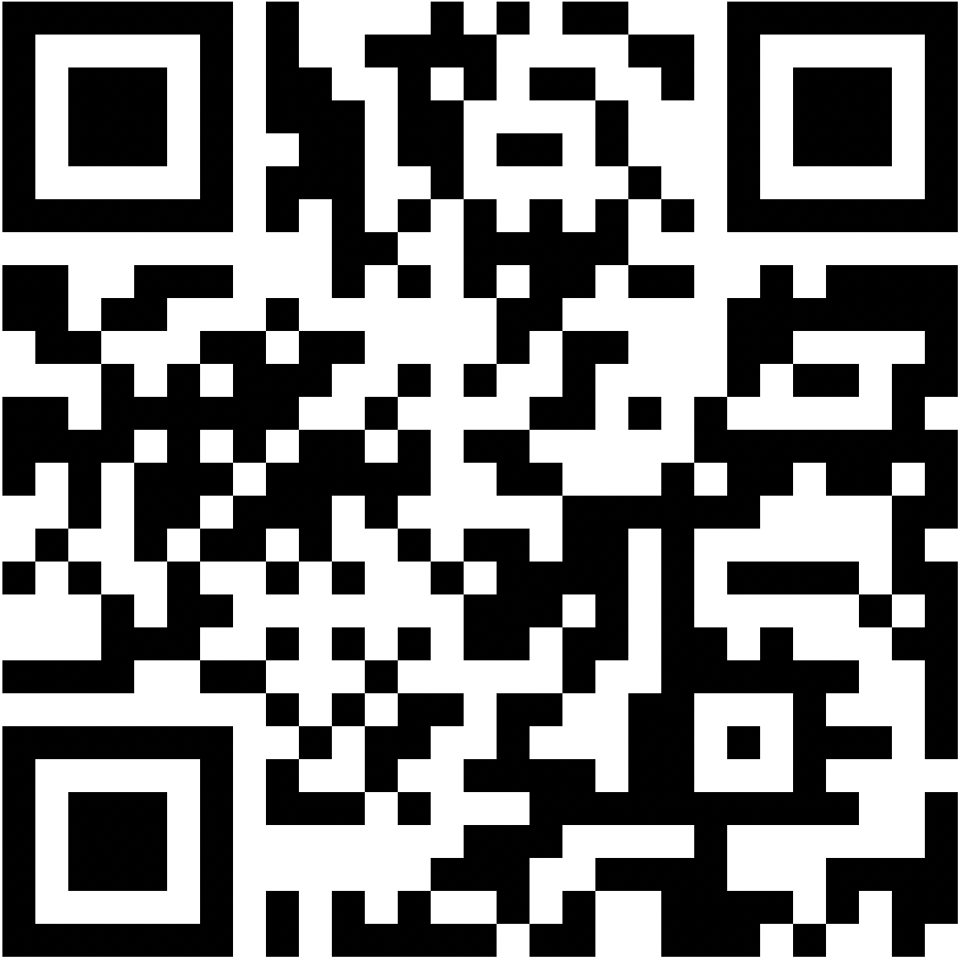

Appendix B
Example Google Songmakers
In this Appendix, examples of the Google Songmakers are provided. They are embedded as virtual links and snapshots are shown in Figures B1, B2, and B3. These Songmakers will be used as examples in the course and are intended to provide a visual model for students to use as a guide as they progress through the workshop.
Songmaker Examples:
- C Major Scale
  - Used to introduce the color-coded music literacy system during the introductory Songmaker lesson on Day 1 of the workshop
Figure B1:
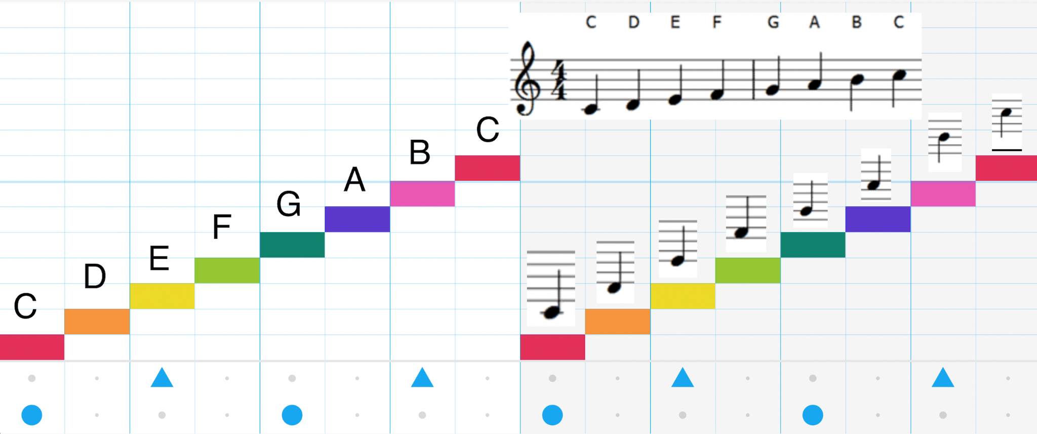
- Thunder by Imagine Dragons Songmaker:
  - Used during the “mock” lesson on Day 1 of the workshop
  - Click link: https://musiclab.chromeexperiments.com/Song-Maker/song/6264097259913216
- Levitating by Dua Lipa
  - Used during the introductory Songmaker lesson in Day 1 of the workshop
  - Click link:
https://musiclab.chromeexperiments.com/Song-Maker/song/6312947412631552
Figure B2:
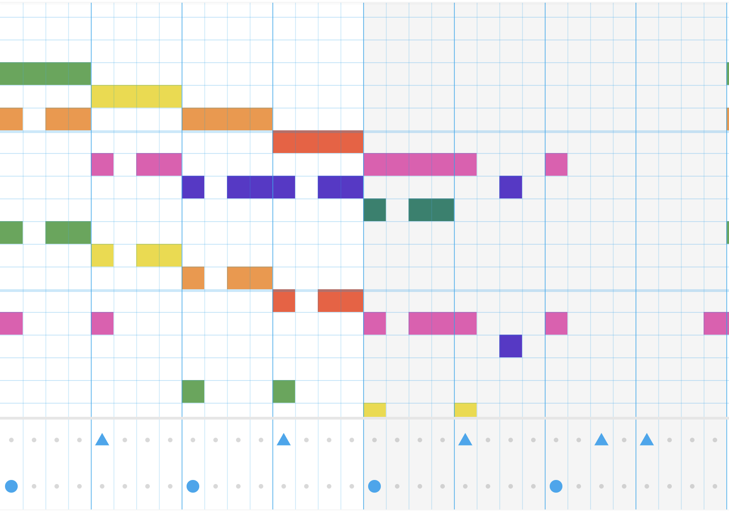
- Never Gonna Give You Up by Rick Astley
  - Used during the introductory Songmaker lesson in Day 1 of the workshop
  - Click link: https://musiclab.chromeexperiments.com/Song-Maker/song/6657564380495872
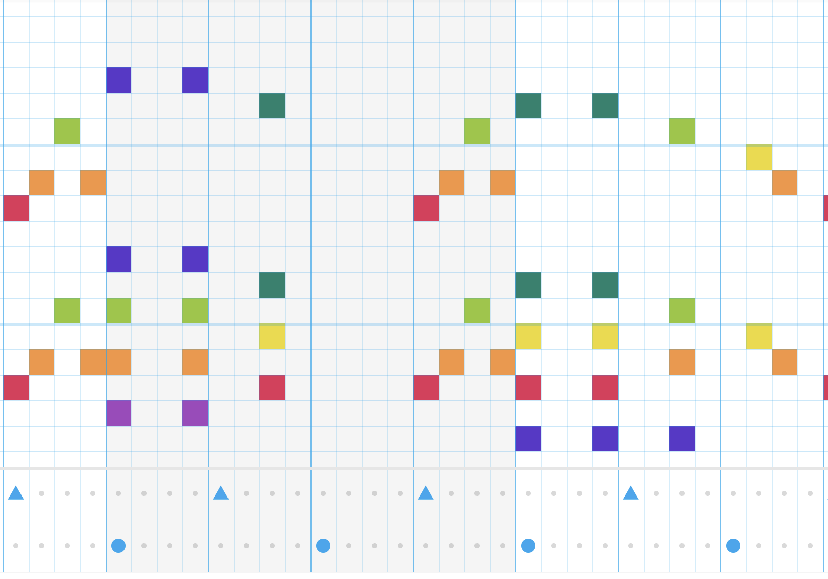
Figure B3

Appendix C
Group Lesson Unit Rubric and Outline
The following the rubric and outline will be used during days two and three of the workshop as participants design and develop their group lesson unit. Figure C1 shows the rubric that will serve as the summative evaluation of the course and Figure C2 shows the outline students can use as a guide during the group project.
Figure C1
Group Lesson Rubric -
Assignment: Participants will be assigned groups of 5-6 people to design and develop a 20 - 25 minute lesson utilizing Google Songmaker as an instructional tool.

Category | Basic | Proficient | Distinguished
Music Concepts | Participants choose 1-2 music concepts to teach in the lesson. Concepts are vague, and un-noticeable in the unit presented inaccurately, and do not with Google Songmaker. | Participants choose 2-3 music concepts to teach in the lesson. Concepts are defined, noticeable in the unit, presented semi-accurately, and connect with Google Songmaker. | Participants choose 3-4 music concepts to teach in the lesson. Concepts are well-defined, identifiable in the unit, presented accurately, and connect with Google Songmaker.
Use of Songmaker | Participants does not utilize Songmaker as an instructional tool and resource in their unit. There are 0-1 different types of Songmakers in the unit to enhance the overall lesson unit. | Participants utilize Songmaker as an instructional tool and resource in their unit. There are 1-2 different types of Songmakers in the unit and all are utilized to enhance the overall lesson unit. | Participants strongly utilize Songmaker as an instructional tool and resource in their unit. There are 2-3 different types of Songmakers in the unit and all are utilized effectively to enhance the overall lesson unit.
Unit Design | The unit is composed of 2-3, 5-10 minute “mini” lessons that focus on different musical concepts. Concepts and objectives are vague, and the sequencing and scaffolding are lacking throughout the lesson. Some elements of National Music Standards (i.e. creating, performing, responding, and connecting) are present. | The unit is composed of 3-4, 5-10 minute “mini” lessons that focus on different musical concepts. Concepts and objectives are described, and the sequencing and scaffolding are average throughout the lesson. Most elements of National Music Standards (i.e. creating, performing, responding, and connecting) are present. | The unit is composed of 4-5, 5-10 minute “mini” lessons that focus on different musical concepts. Concepts and objectives are well-defined, and the sequencing and scaffolding are exceptional throughout the lesson. All elements of National Music Standards (i.e. creating, performing, responding, and connecting) are present.
Team Collaboration | A few members contribute to the design and development of the lesson unit. A few members present and teach a music concept. Team collaboration is lacking in communication, presentation, and overall performance. | Most members contribute to the design and development of the lesson unit. Most members present and teach a music concept. Team collaboration is somewhat evident through communication, presentation, and overall performance. | Each member contributes to the design and development of the lesson unit. Each member presents and teaches a music concept. Team collaboration is evident through communication, presentation, and overall performance.
Presentations | Presentation is not rehearsed and each member is not equally represented during the performance. An understanding of Songmaker is lacking | Presentation is somewhat rehearsed and each member is somewhat represented during the performance. An average understanding of Songmaker is demonstrated. | The presentation is well-rehearsed and polished, and each member is well-represented during the performance. An exceptional understanding of Songmaker is demonstrated.

Figure C2
Group Lesson Outline
Assignment: Participants will be assigned groups of 5-6 people to design and develop a 20 - 25 minute lesson utilizing Google Songmaker as an instructional tool.

- Lesson unit topic
  - Music Concept 1
    - The person presenting
    - National Standard Addressed
    - Planned lesson sequence
  - Music Concept 2
    - The person presenting
    - National Standard Addressed
    - Planned lesson sequence
  - Music Concept 3
    - The person presenting
    - National Standard Addressed
    - Planned lesson sequence
  - Music Concept 4
    - The person presenting
    - National Standard Addressed
    - Planned lesson sequence
- Songmakers
  - Title of song and link to Songmaker
  - Describe the purpose of every Songmaker
  - Planned lesson sequence
  - List objectives
  - List materials needed
- Unit Design
  - Choose presentation platform (Google Slides, PowerPoint, etc.)
  - Design presentation
Appendix D
Project Timeline
Figure D1 shows the exact project timeline during the implementation phase of the design process. The project timeline is also discussed at length on pages 19-20, however, this is the pamphlet that would be provided to the instructional design team and stakeholders to visualize the workshop design process.

Figure D1
